Activity | Data Type
Number of beatings from Wife | discrete
Results of rolling a dice | discrete
Weight of a person | continuous
Weight of Gold | continuous
Distance between two places | continuous
Length of a leaf | continuous
Dog's weight | continuous
Blue Color | discrete
Number of kids | discrete
Number of tickets in Indian railways | discrete
Number of times married | discrete
Gender (Male or Female) | discrete
Q1) Identify the Data type for the Following:

Q2) Identify the Data types, which were among the following
Nominal, Ordinal, Interval, Ratio.
Data | Data Type
Gender | nominal
High School Class Ranking | ordinal
Celsius Temperature | interval
Weight | ratio
Hair Color | nominal
Socioeconomic Status | ordinal
Fahrenheit Temperature | interval
Height | ratio
Type of living accommodation | ordinal
Level of Agreement | ordinal
IQ(Intelligence Scale) | ratio
Sales Figures | ratio
Blood Group | nominal
Time Of Day | ordinal
Time on a Clock with Hands | interval
Number of Children | nominal
Religious Preference | nominal
Barometer Pressure | interval
SAT Scores | interval
Years of Education | ordinal

Q3) Three Coins are tossed, find the probability that two heads and one tail are obtained?
Ans.
3/8 = 0.375 (37.5%)
Q4) Two Dice are rolled, find the probability that sum is
- Equal to 1
- Less than or equal to 4
- Sum is divisible by 2and 3
Ans.
Two dice rolled =6^2 = 36
- Equal to 1 = 0
- Less than or equal to 4 = Sum is less than or equal to 4 / Two dice rolled
= 6 / 36 = 1/6 = 0.166 (16.66%)
- Divisible by 2 and 3 = Sum is divisible by 2 and 3 / Two dice rolled
= 6 / 36 = 1/6 = 0.16 (16.66%)

Q5) A bag contains 2 red, 3 green and 2 blue balls. Two balls are drawn at random. What is the probability that none of the balls drawn is blue?

Ans. Total no. of balls = 2+3+2 = 7

Two balls are randomly drawn from the bag = (7*6*5*4*3*2*1) /
(2*1) * (5*4*3*2*1) = (7*6)/ (2*1) = 21
If none them drawn two balls are blue = 7-2 = 5
None of the ball drawn is blue = (5*4) / (2*1) = 10
So the probability of None of the ball drawn is blue /
Two balls are drawn randomly from the bag = 10/21

Q6) Calculate the Expected number of candies for a randomly selected child
Below are the probabilities of count of candies for children(ignoring the nature of the child-Generalized view)
CHILD | Candies count | Probability
A | 1 | 0.015
B | 4 | 0.20
C | 3 | 0.65
D | 5 | 0.005
E | 6 | 0.01
F | 2 | 0.120
Child A – probability of having 1 candy = 0.015.
Child B – probability of having 4 candies = 0.20
Ans.
0.015+0.8+1.95+0.025+0.06+0.24 = 3.09

Q7) Calculate Mean, Median, Mode, Variance, Standard Deviation, Range & comment about the values / draw inferences, for the given dataset
- For Points,Score,Weigh>
Find Mean, Median, Mode, Variance, Standard Deviation, and Range and also Comment about the values/ Draw some inferences.
Use Q7.csv file
Q8) Calculate Expected Value for the problem below
- The weights (X) of patients at a clinic (in pounds), are
108, 110, 123, 134, 135, 145, 167, 187, 199
Assume one of the patients is chosen at random. What is the Expected Value of the Weight of that patient?
Ans. Expected Value = Sum(X*Probability of X) =
(1/9)(108) + (1/9)(110) + (1/9)(123) + (1/9)(134) + (1/9)(145) + (1/9)(167) + (1/9)(187) + (1/9)(199) = 145.3

Q9) Calculate Skewness, Kurtosis & draw inferences on the following data
Cars speed and distance
Use Q9_a.csv

SP and Weight(WT)
Use Q9_b.csv

Q10) Draw inferences about the following boxplot & histogram

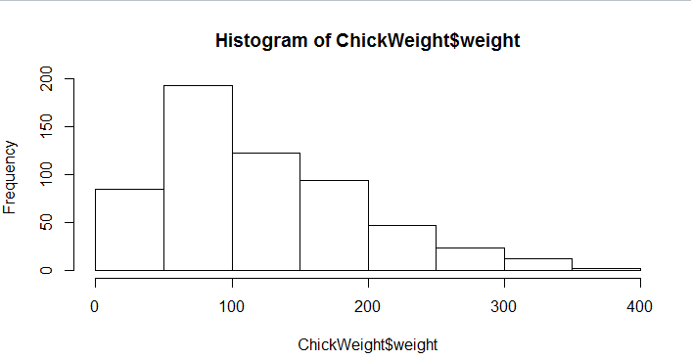
Ans. The histograms peak is right skewed and tail is on right. Mean >
Median and we have outliers on the higher side
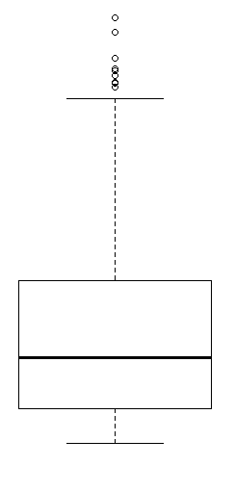
Ans. The boxplot has outliers on the maximum side
Q11)Suppose we want to estimate the average weight of an adult male in Mexico. We draw a random sample of 2,000 men from a population of 3,000,000 men and weigh them. We find that the average person in our sample weighs 200 pounds, and the standard deviation of the sample is 30 pounds. Calculate 94%,98%,96% confidence interval?
Q12)Below are the scores obtained by a student in tests
34,36,36,38,38,39,39,40,40,41,41,41,41,42,42,45,49,56
- Find mean,median,variance,standard deviation.
- What can we say about the student marks?
Ans. It is not having any outliers and the data is slightly right skewed because mean > median
Q13) What is the nature of skewness when mean, median of data are equal?
Ans. When the mean and median are equal no skewness is there and the data is normally distributed.
Q14) What is the nature of skewness when mean >median ?
Ans. Skewness and the tail will be towards right
Q15) What is the nature of skewness when median > mean?
Ans. Skewness and the tail will be towards left
Q16) What does positive kurtosis value indicates for a data ?
Ans. Positive kurtosis means the curve is more peaked and it is Leptokurtic
Q17) What does negative kurtosis value indicates for a data?
Ans. Negative Kurtosis means the curve will be flat and broad.
Q18) Answer the below questions using the below boxplot visualization.
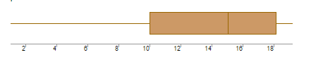
What can we say about the distribution of the data?
Ans. The above Boxplot visualization is not normally distributed and the median is towards the higher value.
What is nature of skewness of the data?
Ans. The data is skewed towards left and the whisker range of minimum value is greater than maximum
What will be the IQR of the data (approximately)?
Ans. IQR = Q3 – Q1 = 18 – 10 = 8
Q19) Comment on the below Boxplot visualizations?
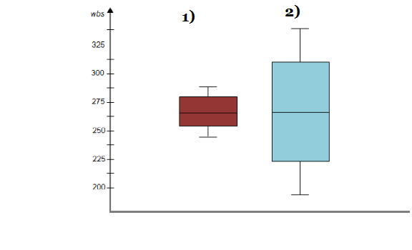
Draw an Inference from the distribution of data for Boxplot 1 with respect Boxplot 2.
Ans. Firstly there are no outliers. Secondly both the box plot shares the same median that is approximately in the range between 275 to 250 and they are normally distributed with zero to no skewness neither at the minimum or maximum whisker range
Q 20) Calculate probability from the given dataset for the below cases

Data _set: Cars.csv
Calculate the probability of MPG ofCars for the below cases.
MPG<- Cars$MPG
  - P(MPG>38)
  - P(MPG<40)
c. P (20<MPG<50)

Q 21) Check whether the data follows normal distribution
- Check whether the MPG of Cars follows Normal Distribution
Dataset: Cars.csv

- Check Whether the Adipose Tissue (AT) and Waist Circumference(Waist) from wc-at data set follows Normal Distribution
Dataset: wc-at.csv

Q 22) Calculate the Z scoresof 90% confidence interval,94% confidence interval, 60% confidence interval
Q 23) Calculate the t scores of 95% confidence interval, 96% confidence interval, 99% confidence interval for sample size of 25
Q 24)A Government companyclaims that an average light bulb lasts 270 days. A researcher randomly selects 18 bulbs for testing. The sampled bulbs last an average of 260 days, with a standard deviation of 90 days. If the CEO's claim were true, what is the probability that 18 randomly selected bulbs would have an average life of no more than 260 days
Hint:
rcodept(tscore,df)
df degrees of freedom

